–

Missouri Evergreen
Consortium

Circulation Procedure
Manual

February 2024
  - Table of Contents
Circulation Guidelines 6
The Patron Record in Evergreen 6
Overview 6
Action Buttons 6
Action Menu 7
Column Picker 7
Printing 7
Creating Notes, Alerts and Blocks 7
Notes 7
Alerts 8
Blocks 8
Adding Notes 9
Removing/Editing/Archiving Messages 10
Patron Registration 11
Patron Search 11
Existing Accounts 12
Merging Patron Accounts 13
Eligibility Types 13
Identity and Address Verification 14
Main (Profile) Permission Group 14
Allow Others to Use My Account—if enabled by your library 14
Address information 15
Creating a New Patron Account 16
Replacement Cards 18
Expired Patron Accounts 18
Online Registration 19
Checkout Procedures 20
Standard Checkout 20
Allow Others to Use My Account—if enabled at your library 21
Special Checkout Circumstances 21
Specifying a Different Due Date 21
Editing a Due Date 22
Checking Out Non-Cataloged Items 23
Barcoded Item Not Found in the Catalog (Pre-Cataloging) 23
Renewals 24
Renewing Through a Patron Account 24
The Renew Screen 25
Check In Procedures 26
Standard Check In 26
Checking In Damaged Items 26
Home library item damaged by your patron 27
MEC Item Damaged by Your Patron 27
Home Library Item Damaged by MEC Patron 27
Checking in items with Missing Pieces 28
Checking In Deleted Items 29
Claims Returned and Claims Never Checked Out 30
Routing of Materials 30
Searching the Catalog 30
Basic Search 30
Advanced Search 31
Keyword Search 31
Search Library 32
Numeric Search 32
Search Results – An Example 32
Facets 32
Item Table 34
View Holds 35
Patron View 36
Patron Holds 36
Types of Holds 37
Placing Holds from the Patron Record 37
Title Holds 37
Item Holds (also known as Copy Holds) 39
Part Holds 40
MetaRecord Holds 41
Placing Holds from a Catalog Search 42
Baskets 42
Editing Holds 44
Canceling Holds 44
Suspending and Activating Holds 46
Suspending Holds Indefinitely 46
Suspending Holds Until a Specific Date 46
Pulling Holds 47
Capturing Holds 48
Retargeting Holds 48
Clearing the Hold Shelf 49
Home Library item not found on Hold Shelf 50
MEC item not found on Hold Shelf 50
Hold Groups 50
Bills 51
Paying Bills 52
Voiding a Bill 52
Forgiving a Bill 53
Grocery Bills 55
Lost Items 56
Checking Out When the Internet is Down 56
Appendix – Other Helpful Documents 58
Canceling Transits 58
Checking the Transit List 58
Damaged Items Best Practices 58
Deleting Expired Patron Accounts 58
Finding Shelf Expired Holds that are on Another Library’s Hold Shelf 58
Hopeless Holds 58
How to Spot a Fake/Bootleg DVD 58
Materials Handling Best Practices 58
Missouri Evergreen Circulation Policy 58
Offline Circulation Using Evergreen 58

Circulation Guidelines

The Missouri Evergreen Consortium exists to share resources between its member libraries. The circulation policies of the library where items are checked out apply to those items. The lending library will not apply arbitrary judgement about which patrons at borrowing libraries may and may not borrow materials from the lending library. Patrons will direct questions about borrowed items to their home library, not to the lending library.

The Patron Record in Evergreen

Overview
The patron record screen displays information in three areas:
- Patron information appears on the left. The patron’s name appears at the top left corner of their record. The name will be RED if the patron has holds, overdue materials, alerts, blocks, or bills.
- Action buttons appear along the top of the patron record.
- The right side of the patron record displays information pertinent to the action button selected.

Action Buttons
Along the top of the patron record is a set of action buttons. These buttons allow staff to perform a variety of functions within the patron record.
- Check out – used to check out both cataloged and non-cataloged items.
- Items Out – displays a list of all items currently checked out, items that have gone to bills, and non-cataloged items checked out.
- Holds – displays a list of items requested by a patron, including items ready for pickup, items in transit, holds not yet filled, and suspended holds. An additional button allows staff to view Recently Canceled Holds.
- Bills – displays bills on a patron’s account and allows access to bill history.
- Notes – displays notes, alerts, and blocks on a patron’s account. For more detailed information, see Creating Notes, Alerts, and Blocks.
- Edit – allows staff to update a patron’s information and extend the account expiration date.
- Other – allows more advanced options in a patron’s account, such as creating/breaking patron groups, viewing Hold Groups, and purging accounts.

Action Menu
Each of the screens in the patron account, except Checkout and Edit, has an Action menu. This menu gives staff access to commands to perform on selected items in the list. These commands will vary depending on which screen is selected.

Column Picker
Each screen, except Edit, has the Column Picker on the far right of the screen. This button allows staff to select specific columns to display on the screen. The column choices will vary depending on which screen is displayed. If a checkmark appears by an item in the Column Picker list, that column is displayed on the screen. In some pages, the Column Picker is a small downward pointing arrow. In others, it is a gear.

Patron Check Out screen Column Picker  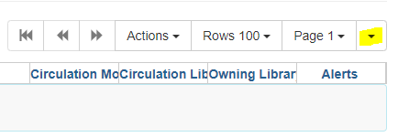 | Staff Catalog record screen Column Picker 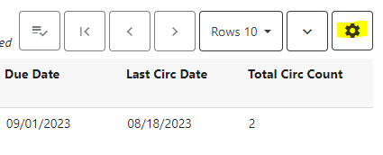

Printing
Information from patron screen pages can be printed by clicking the Print button, if available, or by selecting Print Full Grid from the Column Picker dropdown menu.

Creating Notes, Alerts and Blocks
Three kinds of notices can be added to a patron’s account.

Notes
Notes are for information only. They do not automatically appear on a patron’s account when the account is accessed. Staff must click on the Notes tab to see the note. For example, a Note is created when a patron has been forgiven for a Lost item. The Penalty Name for Notes is SILENT_NOTE and will appear as such in the patron’s list of Notes.
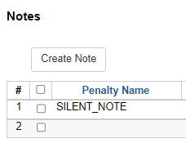

Alerts
Alerts contain information that staff need to see immediately when the patron account is accessed. When there is a staff created alert on the patron’s account, the patron name appears in RED. Staff may add Alerts for a variety of reasons, for example, a library card was found in the parking lot or to explain why the patron has been charged for damage. Hovering the mouse over the title of the Alert will cause the text of the Alert to display. The text may also be viewed in the Notes button.
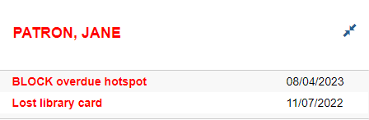
Some Alerts are automatically generated by the ILS, such as notes about available holds, bills and expired accounts. These alerts cause a STOP sign to appear on the patron’s home screen and also create a RED patron name.
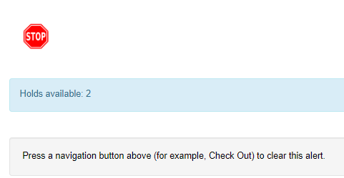

Blocks
Blocks restrict a patron from checking out, renewing material, and placing requests, as well as blocking access to any service or device that uses SIP authentication (for example, public computers and eBooks). Blocks are added to patron accounts by the ILS when the patron has fines or the account is expired and by staff when patrons have violated library behavior policies.
If staff attempt to check out materials to a patron and see the pop-up message STAFF_CHR, they will know that the patron has a block on the account created by STAFF and that the account is blocked from Circulation – Holds – Renewals (CHR).

Adding Notes

- Select Notes in the patron’s account.
- Click Create Note.
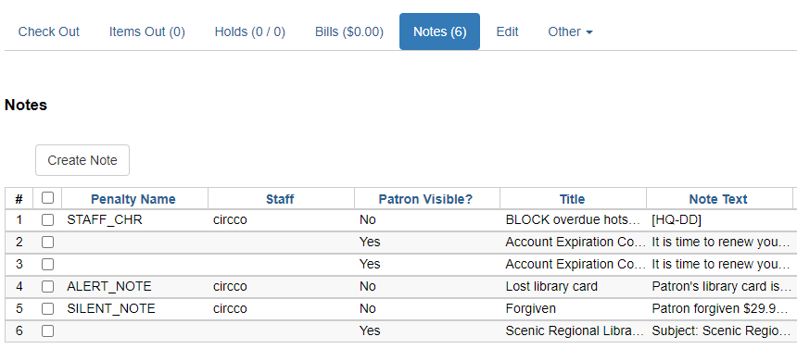
- Select Note, Alert, or Block.
- If you want the patron to be able to read the note in his online account, check the Patron Visible box.
- Leave the Depth and Location fields as they default. (Change as needed.)
- In the Title box, enter a few words to explain the Note/Alert/Block.
- In the Note Text box, enter a detailed explanation.
- If required by your library, enter staff identifying information in the Initials box.
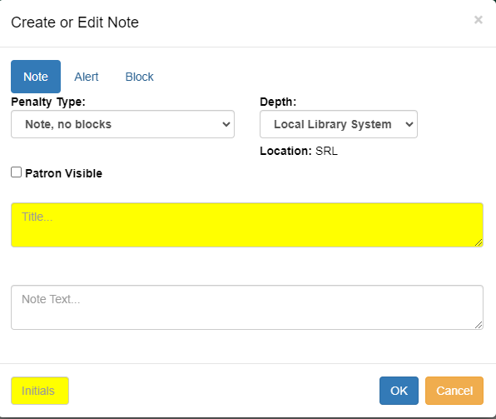

Removing/Editing/Archiving Messages

- From the patron’s Notes screen, select the Note that needs to be edited, removed, or archived.
- Use the Actions menu to select the action that you want to perform.
- Removing the note deletes it from the patron’s account. Notes marked Read by patrons cannot be Removed.
- Edit Note allows you to change the text in the Title and the Note Text fields and to change the type of note, for example, changing an Alert to a Note.
- Archiving the note moves it to the Archived Notes field at the bottom of the Notes page.

Alerts created by the ILS are removed automatically by the ILS when the issue is resolved. Alerts about account expiration disappear when the account is updated. Alerts about bills disappear after fines have been paid.
Courtesy notices created by the ILS are NOT automatically removed. These notices include notification that holds are ready for pick up and that the account is about to expire.
Notes, Alerts, and Blocks created by staff and courtesy notices created by the ILS may be Removed, Edited, or Archived. These functions are found in the Actions menu.
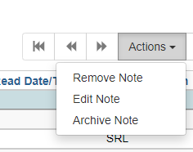
IMPORTANT: Notes need to be thorough so that any staff person reading them knows exactly what is going on in the patron’s account. This is an example of an Alert about a damaged item.
Title: DAMAGE
Note Text: One Dark Night by Leon Sweep, 3001234567, pages 115 through 205 have extensive liquid (coffee?) damage. Item will be held at WC until March 15, 2019 – 1/15/2019Initials: WC-AZ

Patron Registration

Each library district uses its own criteria to determine who is eligible for library services. Before registering a patron for a library card, make sure to verify that the patron meets the requirements set by your library.

Patron Search
Before registering a patron for a library card, ensure that the individual does not already have an account. Follow these steps:

- Click on Search for Patrons in the Search menu or Search for Patron by Name in the
Circulation and Patrons column of the Evergreen home page.
- If only one row of search fields appears, click the down arrow at the right of the search
fields to Show More Fields. See picture on following page.
- Make sure that the box next to Include inactive patrons? is checked. Inactive accounts
can easily be reactivated rather than creating a new account.
- Following your library’s preference, either search all of ME or only your library.
- Type in a few letters of the patron’s last and first name. The entire name doesn’t need
to be entered.
- Click the blue Search button.
- Verify possible duplicates by comparing birthdates and addresses.

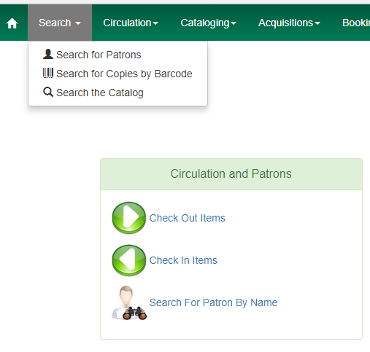

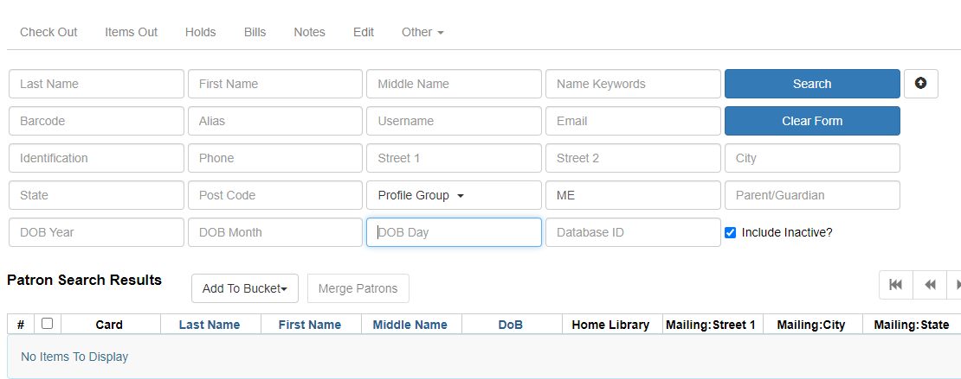
Note: It is possible to search for patrons by entering pertinent information in any of the search fields (address, DOB, phone number, etc.). There is a search field for parent’s name that will help staff find all children registered by the same parent, if staff have entered a name in the patron’s Parent/Guardian field.

Existing Accounts
If a patron has an existing account and needs a replacement card or owes money to the home library, follow the home library policy for replacing the card or paying for lost or damaged materials.

Requests from patrons who currently have an account at another Missouri Evergreen library may be created, as long as the patron does not have outstanding charges on other Missouri Evergreen accounts. If other Missouri Evergreen accounts are found and there are outstanding charges that exceed your library’s fines/fee threshold, ask the patron to pay or reconcile charges on their other accounts before creating another account.

If it is discovered that a patron has multiple accounts at the home library, all accounts should be merged into the account the patron used most recently. Only merge home library accounts. Do not merge accounts created at different library systems

Merging Patron Accounts
- Perform a Patron Search to find the accounts that need to be merged.
- Select the accounts to be merged.
- Click the Merge Patrons action button.
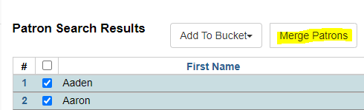
- The resulting screen will show the details of the accounts to be merged.
- Fill in the radio button for the account that you want to Use as Lead.
- Click the Merge button at the bottom right of the page.
- Bills, checked out items, holds, notes, and circulation history will merge into one account.

C. Eligibility Types

Eligibility Types
Each library district uses its own criteria to determine who is eligible for library services. Eligibility types include people who live in a specified geographic area, people who pay out-of-pocket for library access, and people who live in a library district with which the library of application has a reciprocal agreement. When registering a patron, an eligibility type is selected at the bottom of the Evergreen registration page – Statistical Categories > Patron Type. Below is an example of patron types at a Missouri Evergreen library. The selection made from this menu does not affect patron access to services. It is for statistical purposes and to enable information gathering through reports.

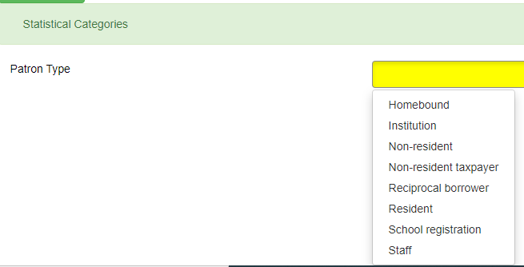

Identity and Address Verification
Each library district uses its own criteria for verifying patron identity and residence. Identity, for example, can be verified with a government or work photo ID. Residence can be verified with a government ID or document, a utility bill, a printed check, or a piece of mail. Additional verification may be required when determining if a patron is living inside a library’s tax district.

A parent or legal guardian is required to be present in order for a library account to be created for a patron under the age of eighteen. The parent/guardian provides verification of the parent/guardian’s identity and residence. The parent/guardian’s name should be entered in the parent/guardian field of the registration page.

Main (Profile) Permission Group
The selection made from this menu tells Evergreen what the patron has permission to do. In this example, Patrons may check out 100 items, Internet Only patrons may only use eResources, and Probationary Patrons may check out three items and their accounts expire in three months.

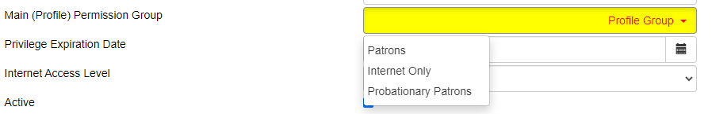

Allow Others to Use My Account—if enabled by your library
When registering a new patron, ask if they want to allow others to use their library account to Place Holds, Pick Up Holds, View Borrowing History, and/or to Check Out Items. The purpose of this feature is to allow caregivers and family members to pick up holds and check out materials for the patron, while also protecting the patron’s privacy. It does not replace the need for each family member to have their own account. Make sure patrons know they are responsible for everything checked out on the account.

If the patron wants to give someone else permission to use the account, click the green Add Person button, enter the name of the person(s) who may use the account, and check the box(es) to indicate what the person may do. When the Allowed Other presents items at the service desk to be checked out on the patron’s account, verify that person is listed as someone allowed to use the account and verify that person’s identity by viewing ID, if the person is not known to staff.
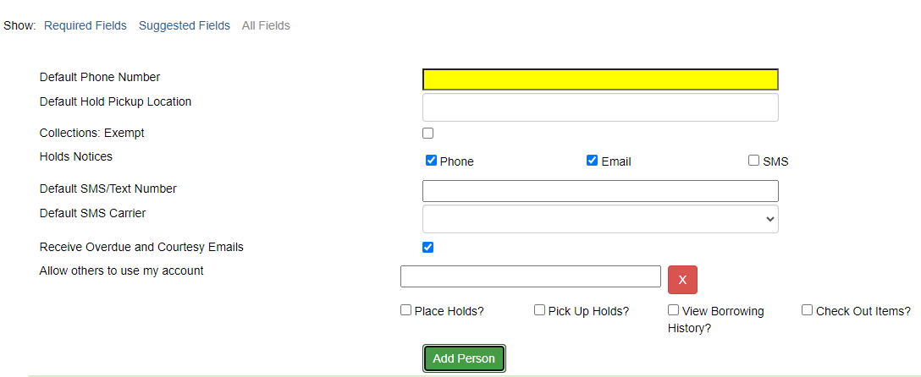

Address information
Some patrons may not receive mail where they reside. In those cases, enter a Mailing address then open New Address to enter a Physical address. Check the appropriate check boxes (Mailing/Physical) and enter the correct type in the Type field.

Individuals in the Safe At Home program or other domestic violence shelters are not required to provide a residence address, but should provide documentation of their involvement in the program. Safe At Home is a state program that provides anonymous shelter to victims of domestic abuse. Participants are given a PO Box in Jefferson City.
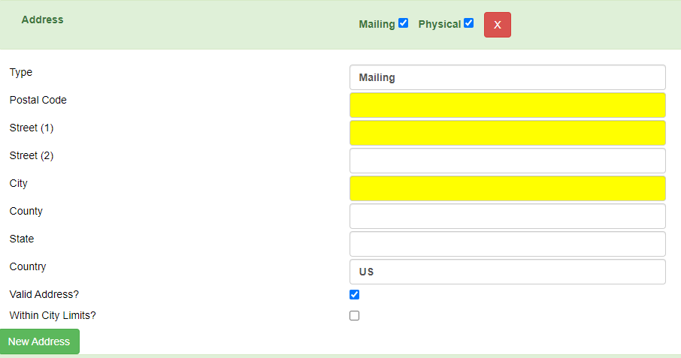

Creating a New Patron Account
The fields of the registration form are shown below with general suggestions for completion.

Identifying Information
Barcode | Scan the new library card barcode
OPAC Username | Will automatically populate with the barcode from above
Password
Prefix/Title | Enter prefix or title if patron’s requests it
First Name | Enter the patron’s first name
Middle Name | Enter the patron’s middle name
Last Name | Enter the patron’s last name
Suffix | Enter suffix (Jr., II, etc.) if the patron’s name includes one
Preferred Name | Enter if patron goes by a different name than on ID
OPAC Alias
Date of Birth | Enter DOB in this format - mm/dd/yyyy
Juvenile | Will automatically check if patron is under 18-years-old
Parent/Guardian | Enter parent’s first then last name if patron is under 18
Primary ID Type | Choose from the dropdown menu
Primary ID | If you chose “Other” above, enter the type of ID used (If required by your library)
Secondary ID Type | If the Primary ID doesn’t verify address, select Other here
Secondary ID | Describe address verification here (If required by your library)
Email Address | Ask if the patron would like to provide an email address
Email checkout receipts by default | Ask if the patron would like receipts emailed
Daytime Phone | Enter a phone number including dashes
Evening Phone | Enter a second phone number if offered by patron
Other Phone
Home Library | Defaults to the workstation location – change if necessary
Main (Profile) Permission Group | Select the appropriate group from the dropdown menu
Privilege Expiration | Will automatically populate – change if necessary
Internet Access Level
Active | Leave checked
Barred | Leave unchecked
Is Group Lead
Claims Returned
Claims Never Checked Out
Alert Message
User Settings
Default Phone | Enter phone number including dashes
Default Hold Pickup | Select a location from the dropdown menu
Collections:Exempt
Hold Notices | Ask the patron’s notification type preference and check the box(es)
Default SMS/Text | Enter mobile phone number if text notification is selected (No dashes)
Default SMS Carrier | Choose a carrier from the dropdown menu is text is selected
Receive … emails | Ask if the patron wants to receive email courtesy notices
Allow others to use my account | If allowed by your library policy, ask the patron if others should be allowed to pick up items for the patron. Click Add Person and complete the information if the answer is Yes.
Address
Address | Leave both boxes checked if the patron receives mail at physical address
Type | Leave field populated with Mailing
Postal Code | Enter the Zip Code
Street (1) | Enter the street address
Street (2)
City | Will populate when Zip Code is entered.
State | Will populate when Zip Code is entered.
County | Will populate when Zip Code is entered.
Valid Address?
Within City Limits
Statistical Categories
Patron Type | Select the patron type from the dropdown menu

Replacement Cards
If a patron has lost their library card, a new number may be assigned to the account and a new card issued.

- Verify the patron’s identity.
- Open the Patron Search screen.
- Make sure that the box next to Include Inactive? is checked.
- Search for the patron’s record.
- Check the box next to the patron’s name to retrieve the account.
- Click the Edit button.
- Click the Replace Barcode button.
- Scan a new library card into the Barcode field.
- Each library has its own procedure for replacing or not replacing the OPAC User Name.
- Make any necessary changes to the patron’s information.
- It is a good idea to update the account expiration date while making these changes.
- Click Save.

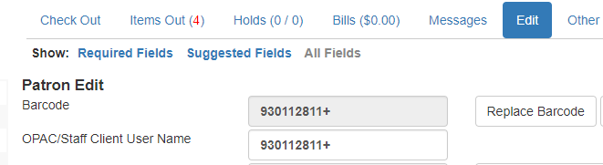

Expired Patron Accounts
Patron accounts expire on the anniversary of the creation of the account. Libraries have the option to send a courtesy notice to patrons, warning them that their account is about to expire and that they need to contact the library to extend their privileges. Expired accounts cannot be used to check out materials or use digital services.

To update the expiration date, open the patron’s Edit screen, ask the patron to verify all contact information and hold notification information. Make any necessary changes then click Update Expiration Date. Click Save to save new data and the new expiration date.

Online Registration
Some libraries allow patrons to register for an Internet Only library account online through the Online Public Access Catalog (OPAC). This registration will allow staff to create an account that will give patrons access to online resources. If patrons want to also check out physical materials, they may submit an online registration and then bring photo ID and proof of residence to the library to upgrade their permissions from Internet Only (online resources only) to a full access account.

Staff check the Pending Patron file in the Circulation tab every day to see if new registrations have been submitted.

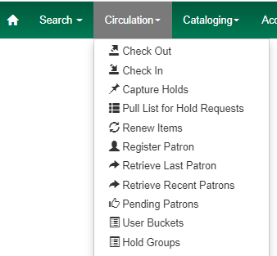
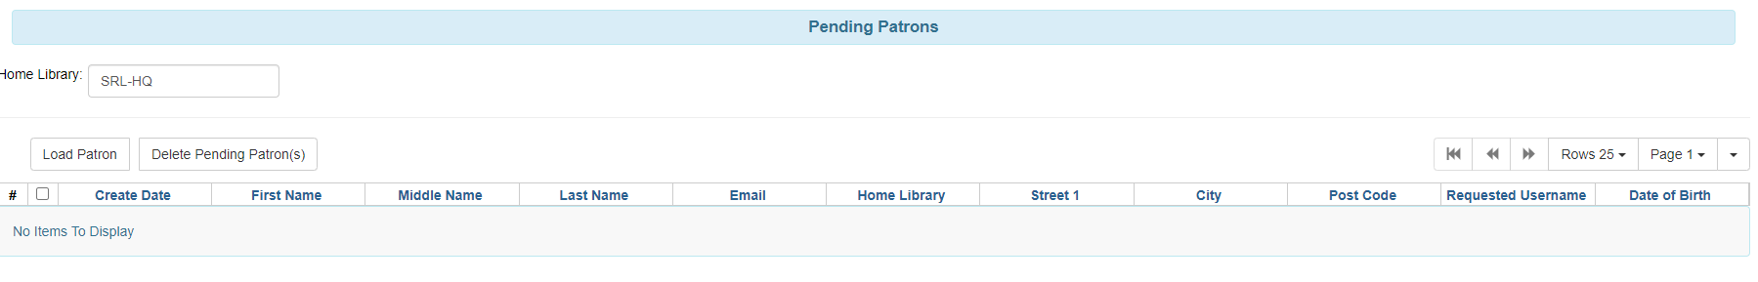
- If there is a pending patron in the Pending Patron list, perform a Patron Search to make sure the patron doesn’t already have an account.
- If he does have an account, contact him to let him know.
- If the patron doesn’t have an account and doesn’t live in your service area, contact him to let him know how to obtain access to library materials and other resources.
- If the patron doesn’t have an account and lives in your service area, click Load Patron. The patron information will be loaded into a Patron Registration form.
- Complete the Patron Registration form. The Patron Permission group must be Internet Only. This allows patrons to use online resources but not check out physical materials.
- Based on your library settings, a patron who has provided an email address may receive an email registration confirmation that includes his library account number. He may use that number to access online resources as soon as staff Save the registration. Follow library procedures for mailing a library card and/or other materials to the new patron.
Other suggested best practices:
- Add an Alert to the patron’s account—Title: Internet Only. Text: Date card and materials sent to patron.
- Mailing the card and/or other materials provides address verification. If it is returned as undeliverable, Block the account and email the patron asking them to bring ID and address verification to the library.
- If the patron brings photo ID into the branch to upgrade their account to full use, change the permission group from Internet Only to the appropriate permission group and complete all other information as you do for every patron (primary ID type, default phone, holds pickup location, etc.)

Checkout Procedures

After retrieving a patron’s account either by scanning a library card or searching for the record, an alert may appear. These alerts may need to be addressed before a patron is able to checkout. More information about alerts and notes can be found in Creating Notes, Alerts, and Blocks.

Standard Checkout
Using Check Out in Evergreen, scan the patron’s library card. The left side of the checkout screen displays the patron’s information, including contact information and account status.

Always check items for obvious damage before checking them out to the patron. Ensure that audio-visual materials have all pieces in the case.

Check out items by scanning the barcodes or placing them on the RFID pad. The barcode, due date, and title will appear in the checkout list. Always watch the screen to make sure the ILS is capturing the data for all of the items.

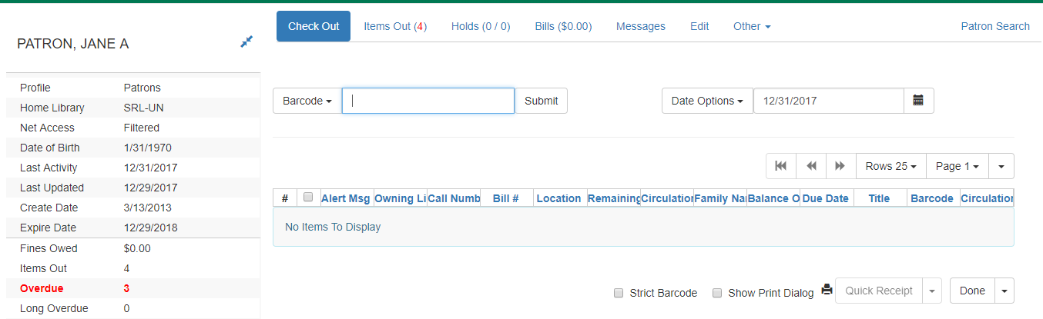

When all items are checked out, ask the patron if a receipt is wanted. If the patron doesn’t want a receipt, use the dropdown menu next to the Done button at the bottom of the screen to select No Receipt. If the patron does want a receipt, click the Done button. A paper receipt will print, or an email receipt will be sent, based on the patron’s preferences. By clicking Quick Receipt, a receipt will print but the account will remain open.

Allow Others to Use My Account—if enabled at your library
If the patron has given permission for someone else to use the account, that information will be found above the patron’s address. Information can also be found about what the person has permission to do.

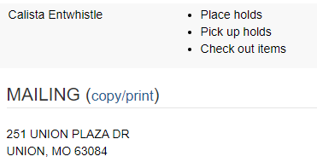

Special Checkout Circumstances

Specifying a Different Due Date
Due dates may be extended in the case of book clubs, outreach, and if a patron notifies staff that they will be on vacation when the item is due. To change the due date, follow these instructions:
    - BEFORE checking out the items that need edited due dates, choose Specific Due Date from the Date Options dropdown menu.
    - !! Caution: Selecting the alternate option, Use Specific Due Date Until Logout will change the due date for all patrons served until the work station is logged out!!
    - Type in the due date or select it by using the calendar widget at the top of the checkout list.
    - Scan or place on the RFID pad all items that need the Specific Due Date.
    - If the patron wants a receipt, click the Done button. A paper receipt will print or an email receipt will be sent, based on the patron’s preferences. By clicking Quick Receipt, a receipt will print but the account will remain open.
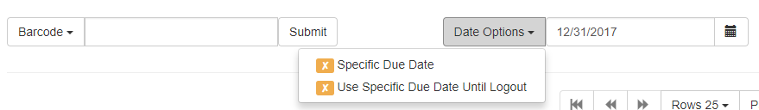

Editing a Due Date
Due dates may be edited after items have been checked out. Editing the due date
should not be used to circumvent renewal limits.

- Open the patron’s Items Out screen.
- Select the item(s) whose due dates need to be edited.
- Select Edit Due Date from the Actions dropdown menu.
- Enter the new due date.
- Click OK.
- The new due date will be reflected in the Items Out screen.

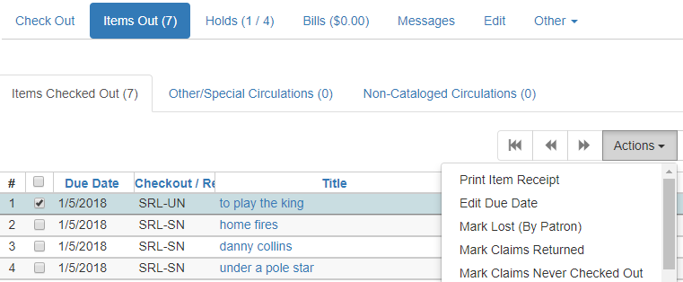

Checking Out Non-Cataloged Items
Some libraries have items that are not cataloged but may be checked out. Examples are fishing rods supplied by the Missouri Department of Conservation, paperback books, and magazines.

From the Check Out screen, click the dropdown arrow beside the barcode field to select the type of non-cataloged item being checked out.
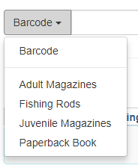
After selecting the correct type, click the Submit button. A window will appear asking for the number of non-cataloged items. Type the number in the box provided and click OK. These items will display in Items Out under the Non-Cataloged Circulation tab.

Before checking out cataloged items to the patron, you must now select Barcode from the dropdown menu to reset the program to accept cataloged items.

Barcoded Item Not Found in the Catalog (Pre-Cataloging)
Occasionally, when an item with a barcode is scanned or placed on the RFID pad, an alert will appear because the item was mis-scanned or it is not in the catalog.

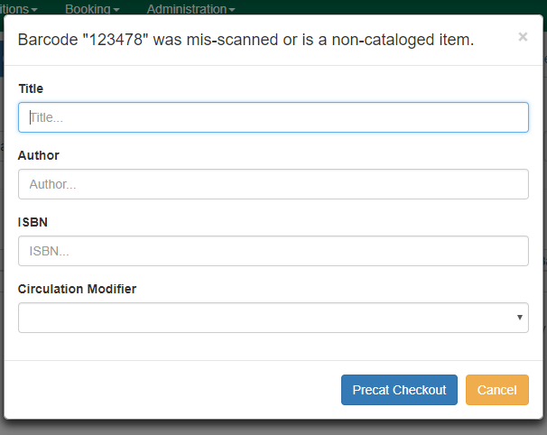
In order to verify that the item was not mis-scanned, click the Cancel button and scan the item a second time. If this alert pops up a second time, complete the Title, Author, and Circulation Modifier fields. The Circulation Modifier tell Evergreen how the item should circulate. Click Precat Checkout.

Renewals

Each Missouri Evergreen library has its own policy governing the number of renewals allowed. An item may only be renewed if there are no hold requests for it and if the renewal limit hasn’t been reached. Renewal limits should not be overridden and no item should be renewed if there is a hold on it. Staff may renew items one of two ways: through a patron’s account or through the Renew screen.

Renewing Through a Patron Account
To renew items through a patron’s account, follow these instructions. Use caution if your library has enabled the auto-renew feature.

            - From a patron’s account, click on the Items Out button. This will display all items currently checked out.
            - Determine which items need to be renewed and select those items.
            - Open the Actions menu and select Renew. If the item or items are eligible for renewal, the due date will update.
            - If a patron requests that all items be renewed, click on the Actions menu and select Renew All. The due date will update for all items eligible for renewal.
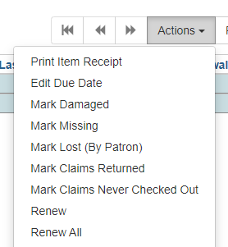

The Renew Screen
This method is ideal when patrons bring materials with them when they come to the library. To renew items though the Renew screen, follow these instructions. Use caution if your library has enabled the auto-renew feature.

      - Access the Renew screen by opening the Circulation menu at the top of the Evergreen home page and selecting Renew Items. This will display the Renew screen.
      - Scan the items to be renewed or put them on the RFID pad.
      - If the item or items are eligible for renewal, the due date(s) will update.

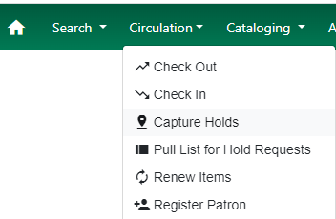

If an item cannot be renewed, a dialog box will popup explaining the reason. If an item has reached the renewal limit or is needed to fill a hold, do not force the action.
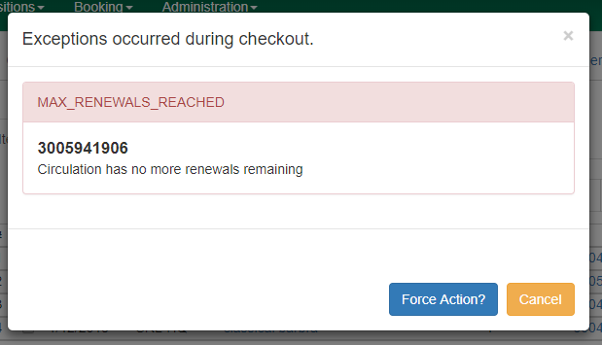

Check In Procedures

When an item is returned or arrives through the state courier, inspect it for damage, make sure all pieces were returned and check it in. Checking in an item will remove the item from a patron’s account or complete a transit, make it available to fill holds, and may initiate routing of the item to another branch or library.

Standard Check In
To check in items, follow these instructions.

      - Open the Check In screen.
      - Scan the barcodes of the items to be checked in or put the items on the RFID pad.
      - Watch the screen to make sure the data is captured.
      - If the item needs to be sent to another branch of library or is filling a hold at your branch, a receipt will automatically print as long as the Auto-Print Holds and Transit Slips Checkin Modifier is turned on.
      - Tuck transit slips inside the middle of items leaving your branch with the destination library’s name visible. Tuck transit slips under the plastic cover of audio-visual materials.
      - Attach Hold Shelf slips to items staying at your branch/library to fill holds.
      - Shelve items that need to be returned to shelves in your branch/library.

Checking In Damaged Items
Over time, library materials begin to show their age. Spines get cracked. Pages discolor. Patrons and borrowing libraries are not charged for normal wear and tear. Individual libraries follow their own policies for charging for damage that is not normal wear and tear. The damaged item should be made available to the patron who caused the damage after the patron has paid for the damage, unless the owning library requests it be returned to them.

When the borrowing library checks in an item that has arrived through the state courier service and notices that the item is damaged before it is given to a patron, an Evergreen Item Condition Report form should be completed and kept with the item (NOT taped to the item). The report form is available on the Missouri Evergreen website. moevergreenlibraries.org.

Home library item damaged by your patron
Check it in and charge the patron according to local policy.

1. Open the Check In screen.
2. Scan the item barcode or place the item on the RFID pad.
3. Once the item shows up in the check in list, select it from the list of items checked in
and either right click or open the Actions drop down menu.
4. Select Mark Item Damaged.
5. A dialog box will pop up showing the automatic Damage fee.
6. Choose Damage from the Type dropdown menu.
7. Add a description of the damage and personal initials to the Notes field.
8. Use Charge Fees and No Charge as dictated by your library’s policies.
9. Click Submit.
- Add a detailed Alert to the patron’s account, including the item barcode number, title, a description of the damage, and where the item is being held. Notify the patron about the bill.
- Follow your library’s procedure for storing and disposing of damaged items.
- Items may also be Marked Damaged from the patron’s Items Out screen and from Item Status.

MEC Item Damaged by Your Patron
If an item belonging another MEC library is returned damaged, check it in, contact the owning library to explain the damage, discuss billing, and find out if the owning library wants the item to be returned or if the checkin library may keep it to show the patron. The borrowing library may neither change the status to Damaged nor Delete materials belonging to other libraries. Only the owning library may perform those functions. Contact information for every MEC library can be found on the website. moevergreenlibraries.org

Home Library Item Damaged by MEC Patron
If an item arrives back at the owning library with damage not addressed by the borrowing
library, mark the item Damaged and notify the patron’s home library that its patron has been
charged for a damaged item. The borrowing library may request photos or other verification of damage and may request that the item be returned to them so that the patron can see it and keep it after it has been paid for. It is the borrowing library’s responsibility to contact the patron and explain the bill on their account. The item may be deleted from the catalog after coordinating with the borrowing library.

Checking in items with Missing Pieces
Carefully check every returned item to make sure all pieces were returned. Each library has its own process governing how staff proceed when an item is returned without all of its pieces.

Check In the item. Choose Scan Item as Missing Pieces in the Circulation dropdown menu on the home page or Mark Missing Pieces in the Check In screen.
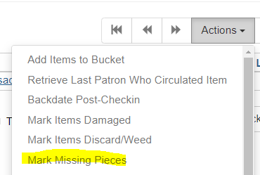
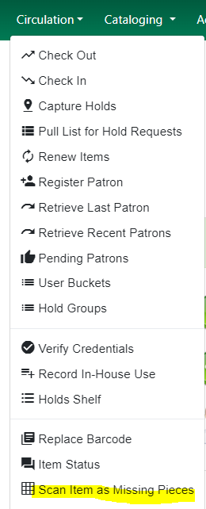

If your library uses these features, complete the fields in the box that results from opening one of them, choosing Note, Alert, or Block as the Penalty Type. The item will be automatically checked out to the last patron to take it home and the status of the item will be DAMAGED or MISSING PIECES depending on your library settings.
Check the patron’s account to verify the process was completed. Unless edited by staff, the patron will be assigned the usual due date and number of renewals for the item type. In the example below, the Penalty Type of Alert was assigned to the note about the missing discs. The Alert appears under the patron’s name in the patron’s record. Be sure to include a detailed description so that all staff understand what is happening with the item.

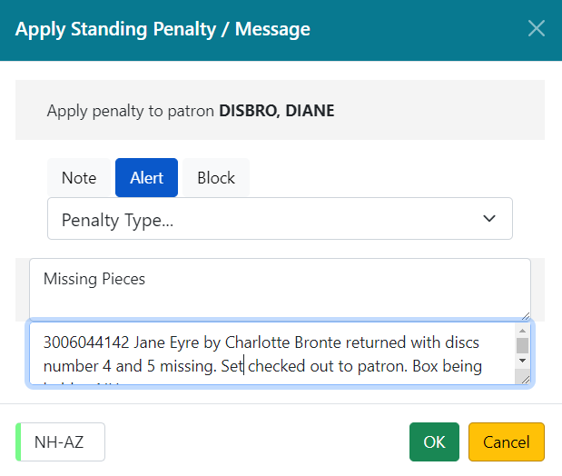
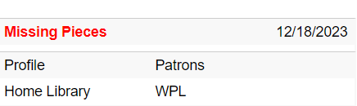

Contact the owning library to ask how long you should keep the item before sending it back and how much to charge if the piece is not returned. Contact the patron to explain the charges.
Since all MO Evergreen libraries do not share the same billing policies, it is important to contact the owning library so they may determine the charge. Add a message in the patron’s record including the title and barcode number, a description of the missing piece, and the name of the owning library so that when the owning library notifies the borrowing library of the fine for the missing piece, there will be a record of the problem.

Checking In Deleted Items
Lost items that have been deleted from the catalog still appear as bills in patron accounts. When patrons return these items, the items scan at check in as “misscanned or not cataloged.”. These items are still in the patron’s Items Out > Other/Special Circulations.

Each library has its own policy about how to handle the return of deleted items.

If you know who returned the item, you are able to remove it from the patron’s account by voiding the bill. Once the bill is voided, the item no longer appears in Other/Special Circulations.

Claims Returned and Claims Never Checked Out
If a patron claims to have returned an item that cannot be found on the shelf, there is the option in the Items Out screen to mark the item Claims Returned. Libraries should use caution when deciding if they will use this feature. Marking it Claims Returned will put the item in Other/Special Circulations where it will stay forever unless the item is checked in. The same is true for Claims Never Checked Out. Many libraries do not use these functions.

Routing of Materials

A courier service supported by the Missouri State Library transfers items between Missouri Evergreen Consortium member libraries. Each Missouri Evergreen library has its own library and branch code.
Transit labels should be printed from the Mid-America Library Alliance website. https://www.malalibraries.org/courier-service/
- Care needs to be taken to use only the up-to-date label for each member library. Slips that were printed months ago and stored in a file may no longer be valid.
- A transit slip must be printed for each item put in the delivery.
See Appendix for Missouri Evergreen Materials Handling Best Practices.

Searching the Catalog

Basic Search
A Basic (Keyword) Search of the catalog can be performed from the Evergreen home page. Enter the partial or complete title, author name, and/or subject to retrieve a wide range of results from which to refine your search. For a successful search, spelling must be accurate.
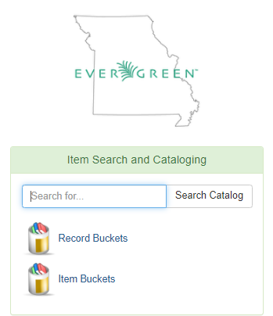

Advanced Search
To perform an advanced search of the catalog, use the Search dropdown menu on the Evergreen home page to access Search the Catalog.

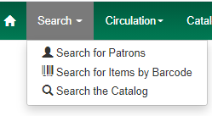
The Staff Catalog page gives you numerous ways to limit your search.

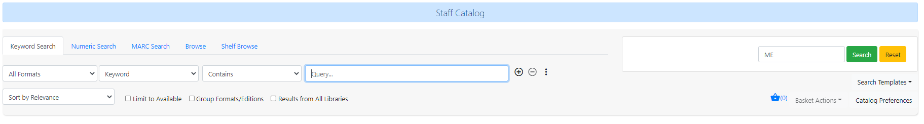

Keyword Search
This is the default on the Staff Catalog page. You can use the dropdown menu to choose to search by Keyword, Title, Journal Title, Author, Subject, Series, and Digital Bookplate. You may also select format and qualifiers for your search terms.
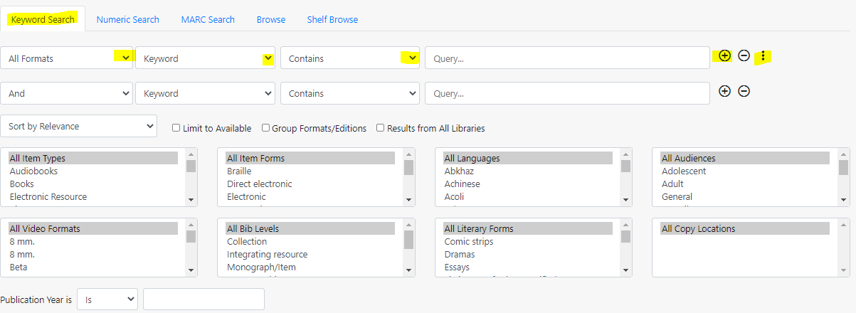

- Use the + if you want to add another row of search limiters.
- Use the three vertical dots if you want to add search options including video type, large print, and publication year. The picture above shows both an extra row of limiters and the additional search factors.
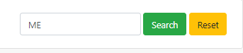
- A broader search is always the best way to begin to look for an item. If you add too many limiters, you may not find what you are looking for because the way an item is cataloged will determine how it will react to a search. If you limit your search to “purple poisonous plants that bloom in May in the Pacific Northwest,” you may get zero results. “Poisonous plants” is a better place to start.

Search Library
Search library should always default to Missouri Evergreen. You may limit your search to a specific library or branch in special circumstances. If you start with a limited search, there is the danger of telling a patron that we don’t have access to an item when we really do; it’s just not at the location you were searching.

Numeric Search
This search will allow you to search for items by ISBN (International Standard Book Number), barcode number, and TCN (title control number).

Search Results – An Example
A Keyword search of all of Missouri Evergreen for All Formats containing the words LINCOLN LAWYER, yields 130 results with ten results per page.

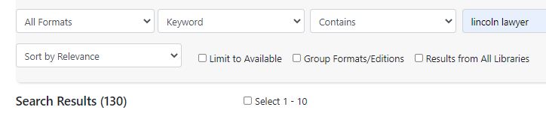

Facets
Facets of the search results appear in a bar on the left side of the results page. Clicking on one of the facets will limit the search results further.
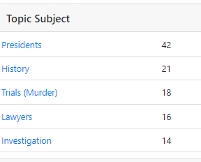
One of the facets found in the search for LINCOLN LAWYER is Topic Subject. Forty-two of the 130 results have “Presidents” in the cataloging as a topic subject. Other items in the 130 results may also be about President Lincoln but if “Presidents” isn’t in the catalog record, those items will not be part of the 42.
If the only LINCOLN LAWYER items that you are interested in are about President Lincoln, click on the link “Presidents” to remove items from the search results that don’t include “Presidents” in the cataloging. The number of items in Search Results is now 42.
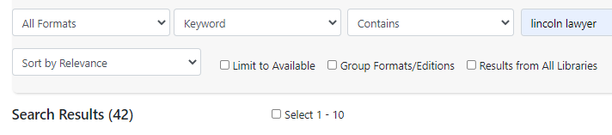

Result #36 of 42 is chock-full of information.
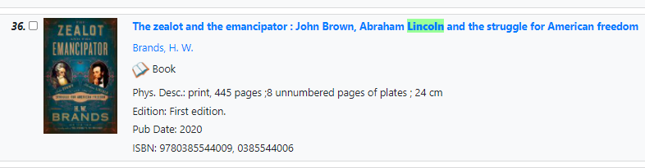
Complete title
Author
Format
Physical Description
Edition
Publication Date
ISBN (International Standard Book Number) associated with the items on the record

.
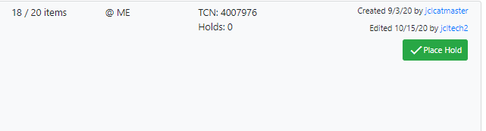

Number of items available / Total number of items on the record (ex. 18 / 20)
Libraries included in your search (ex. all of ME – Missouri Evergreen)
TCN (Title Control Number)
Holds on this record (ex. 0)
Created – when the record was created and by whom
Edited – the last time the record was edited and by whom
Place Hold – click here to place a hold

To find more information about this record, click on the title, which will take you to the Item Table Screen.

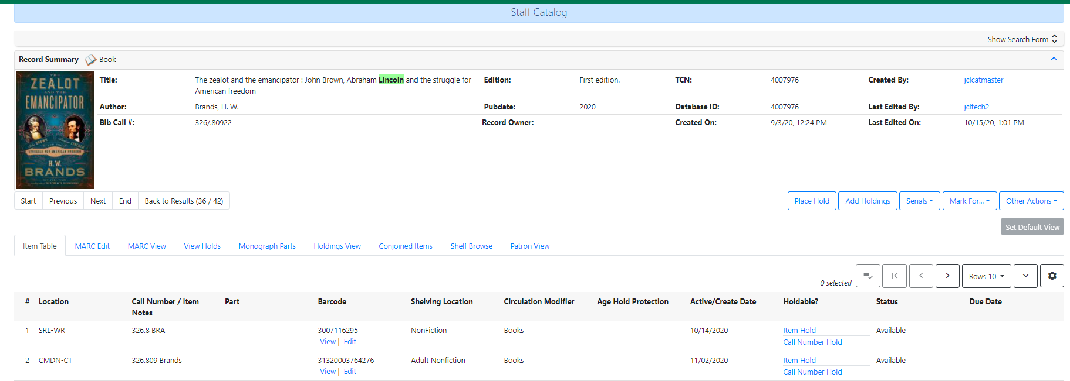

Item Table
Item Table is the default view and shows which libraries own a copy and information specific to each copy (call number, barcode, shelving location, circulation modifier, age protection), activation date, whether or not the item is holdable, status and due date (if checked out).
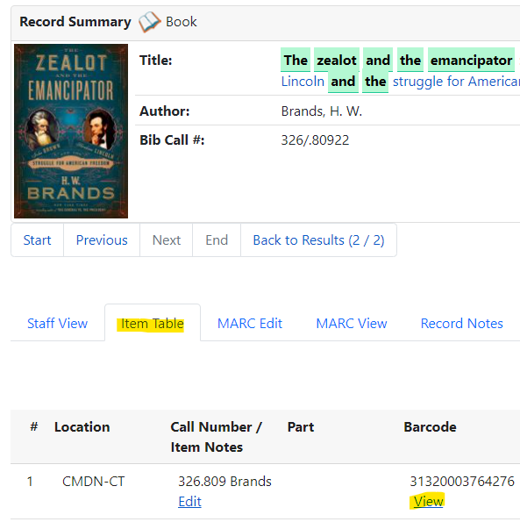

Clicking on View under the item barcode will take you to further information about that item, including the item price and the most recent patron to have the item checked out.

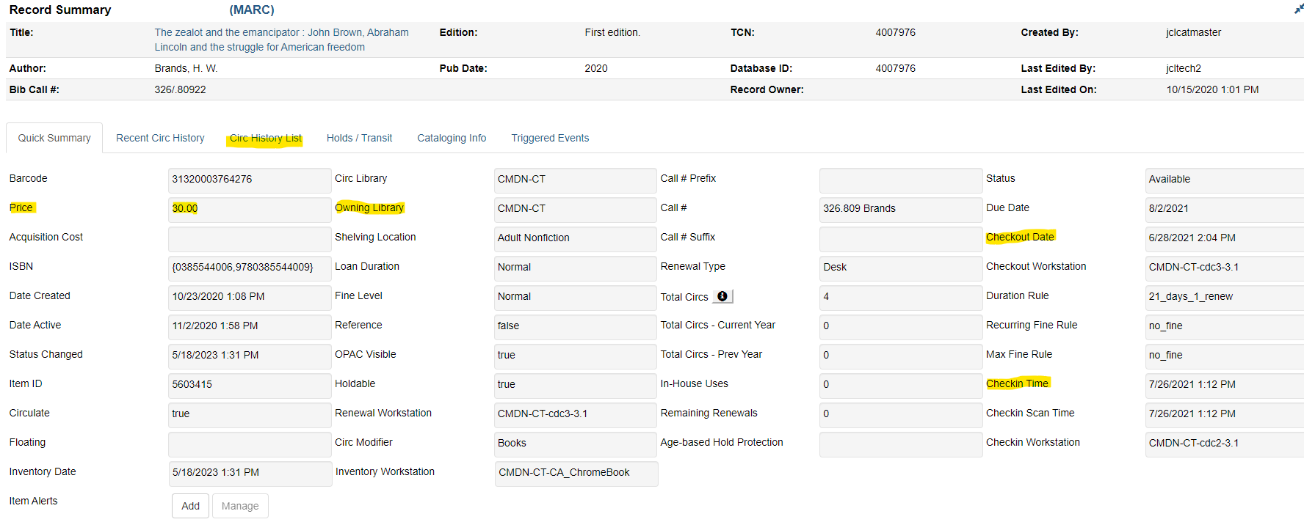

View Holds
Clicking on View Holds allows you to see information about holds.
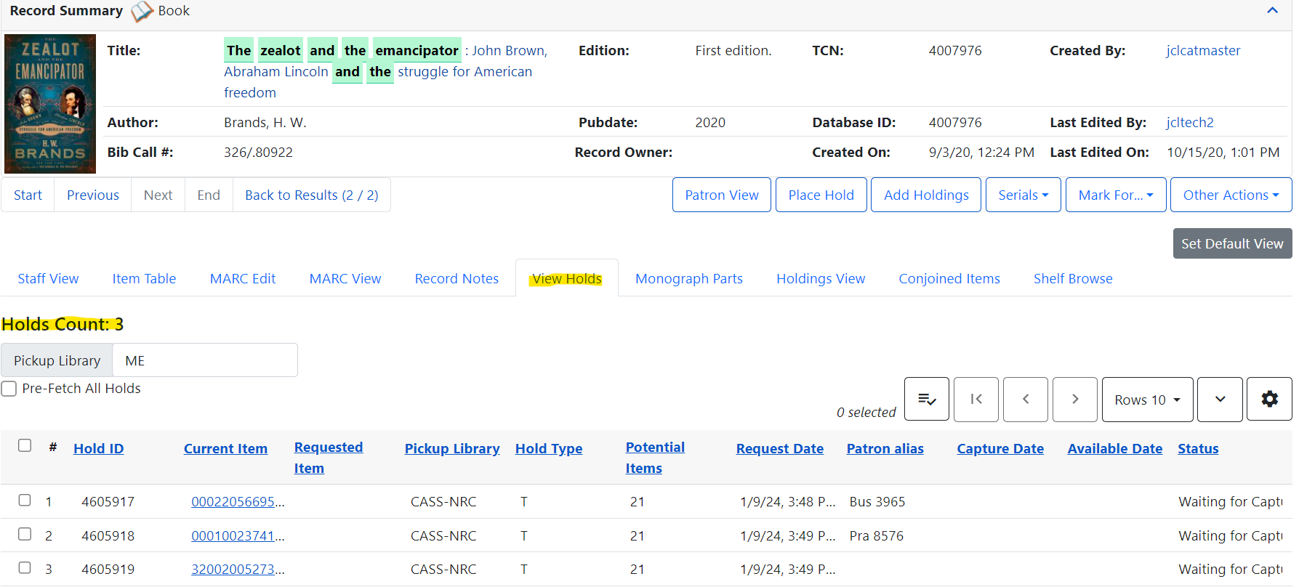

Patron View
Clicking on Patron View takes you to the OPAC (Online Public Access Catalog). Here, you see what patrons see. The page contains a summary of the book and Readers Advisory information. Below the summary is a list of subjects. Clicking on a subject will open a new page of search results with items that share the subject.
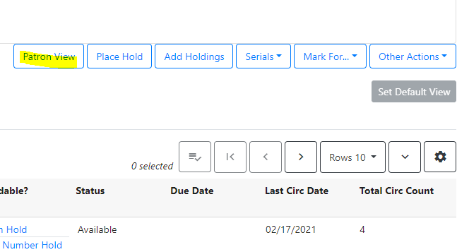
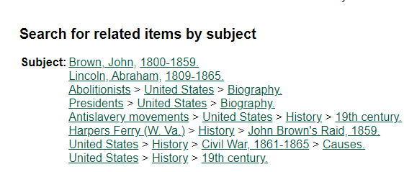

Below the list of subjects, patrons will find additional information provided by Syndetics Unbound. Patrons will be able to see summaries, find information about the author, get professional reviews, see other reviews, write their own review, see a list of titles in a series, read an excerpt and see tags that might help them find other titles to enjoy. Reading Levels are also shown for some titles.

Patron Holds

Patrons may place holds on items through the Online Public Access Catalog, through the mobile app, or by asking staff to place the hold for them. Holds will be filled with items belonging to the patron’s home library or another Missouri Evergreen Consortium member library.
See Appendix for an explanation of Hopeless Holds.

Types of Holds
The chart below describes the different types of holds that can be placed in Evergreen.

Title Hold (T) | Used when a patron wants the first available copy of a title in a specific format. Most holds for books and audiobooks are title holds. | Click on Place Hold. | Patrons or staff may place title holds
Item Hold (C) | Used only when a specific copy/barcode is needed. These holds are used when the cataloging of an item needs to be changed or when you have verified by phone that a specific copy is available to fill a hold. | In the catalog record, click Item Hold for the specific item. | Only staff may place item holds
Parts Hold (P) | Used when a patron wants a specific part of an item, typically a DVD set. | Click on Place Hold. On the confirmation screen, select the part wanted from the dropdown menu. | Patrons or staff may place these holds
MetaRecord Hold (M) | Used to pull the item from a pool of different formats and editions when the patron doesn’t require a specific format or edition. | With formats grouped, click Place Hold, and choose the format(s) the patron wants. | Patrons or staff may place these holds

Placing Holds from the Patron Record

Title Holds
To place a title hold for a patron from their record, choose the Holds action button at the top of the patron record. Then choose the Place Hold button.

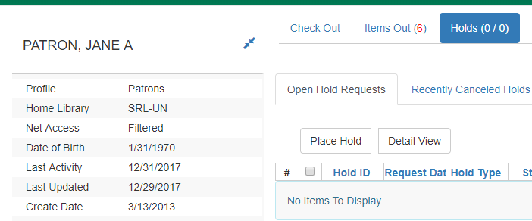
The catalog advanced search screen will appear. By using the advanced search, staff can customize the search in multiple ways. (See Section VII, Searching the Catalog)

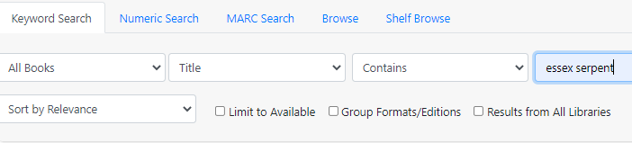

After performing a search, click on the green Place Hold button to place a title hold on
the item.

It is usually best to place the hold on the record that has the highest number of items attached to it. There are three records for the physical book, Essex Serpent. One record has one item attached to it. One record has two items attached to it. One record has seventeen items attached to it. You will see the number of items that are on a record in the search results page (highlighted in the example above). The number shows: items available/total number on record. In this example: 17/17.
After clicking Place Hold, a confirmation screen will appear. The patron’s barcode, default pick up location, and default hold notification preference will appear. Verify with the patron that all the information is correct. Make any needed adjustments.
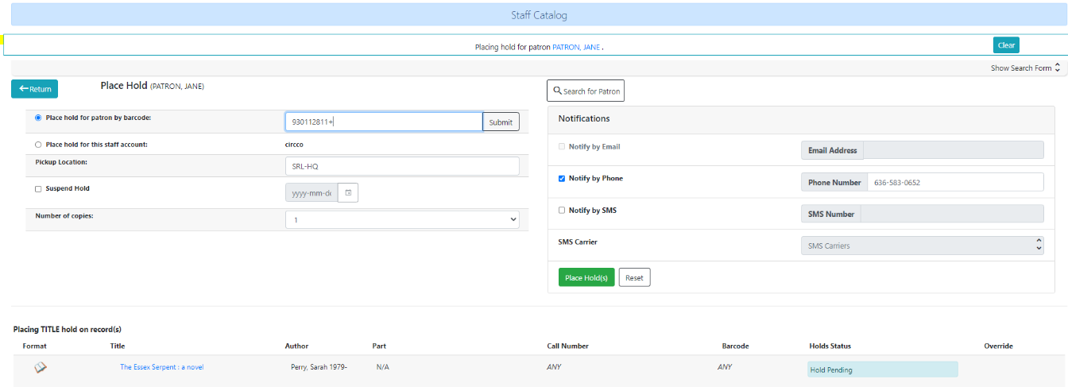
More than one copy of an item may be reserved by changing the default number 1 shown in Number of Copies. This is useful when reserving copies for book clubs. This feature is not available to patrons on the OPAC. Note: Don’t reserve more copies than are attached to the record.
Patrons may want to Suspend the hold if they don’t want the hold to be captured immediately. The hold is suspended by checking the box next to Suspend. An activation date may be selected if the patron knows when they want it to become active. Not selecting a date will keep the item in the patron’s holds list but it won’t be captured until the hold is activated. See Suspending and Activating Holds
Click the green Place Hold button to complete the hold process. Holds Status will turn green and display Hold Succeeded.
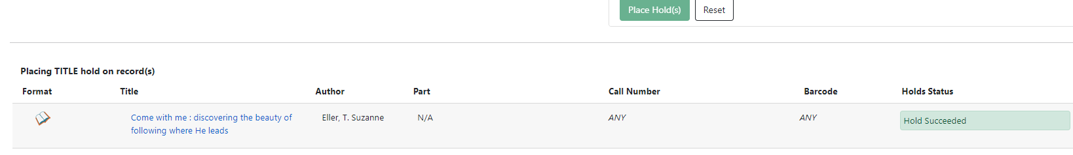

Item Holds (also known as Copy Holds)
If there is a specific copy of an item needed by staff, you can place an item hold from the full catalog record screen. This should only be done in rare circumstances: for example, if an item is needed because of a cataloging error or after you have called the owning library to verify the copy is available and not missing.

After performing a search, click on the title of the item in the catalog. This will bring up a detailed catalog screen. From here, click Item Hold in the Holdable? column.

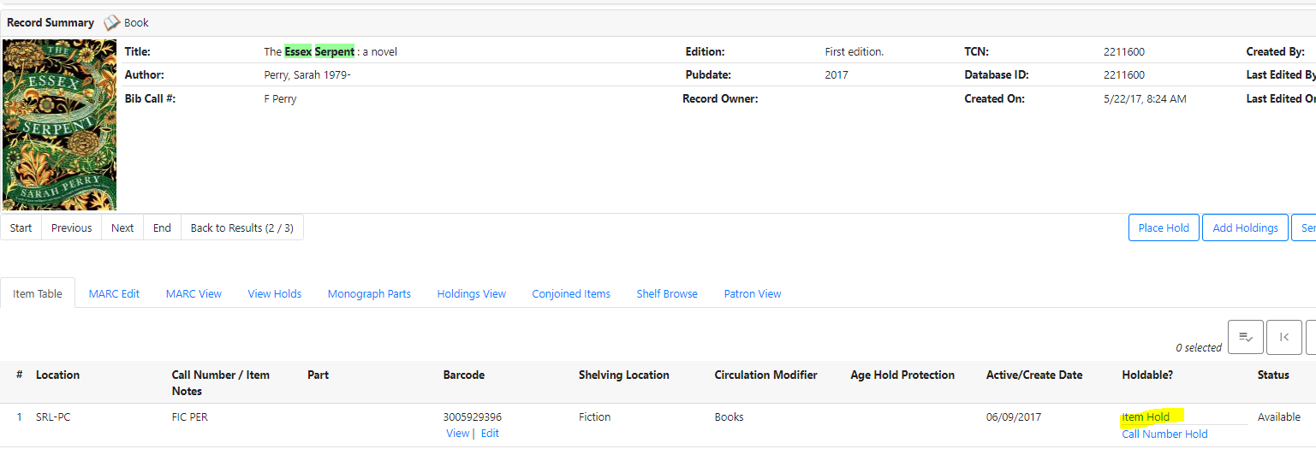
After clicking Item Hold, the confirmation screen will appear. Verify the notification information with the patron. Click the Place Hold button.

Part Holds
If an item has multiple parts or discs, after clicking Place Hold on the search results page, select the part wanted by the patron from the Part dropdown menu.

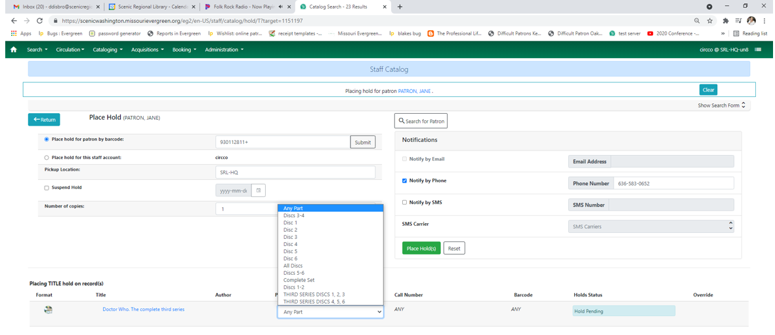

If you attempt to place the hold without selecting a part, this error message will appear.
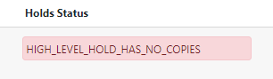
Only one part may be selected at a time. If a patron wants more than one specific part or disc, staff will need to click the browser BACK arrow and place a hold on another part.

MetaRecord Holds
When there are multiple records and/or formats for an item and the patron doesn’t have a format preference, you may place a MetaRecord hold. For example, if a patron wants a copy of The Lincoln Lawyer and will accept a book or audiobook, use a MetaRecord hold. This will place one hold for the patron and the first available item in any of the records with the selected formats will be reserved for the patron.

When performing a search, make sure the Group Formats and Editions check box is checked:
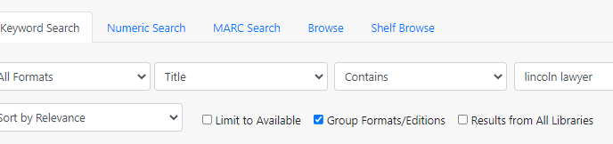

The search results will look like the picture below. Notice the formats. 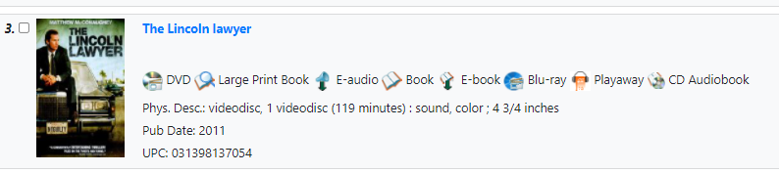
Click Place Hold. A confirmation screen will then appear with a list of item formats. The default is for all formats to be selected. Deselect the formats that the patron won’t accept. Click the green Place Hold button.
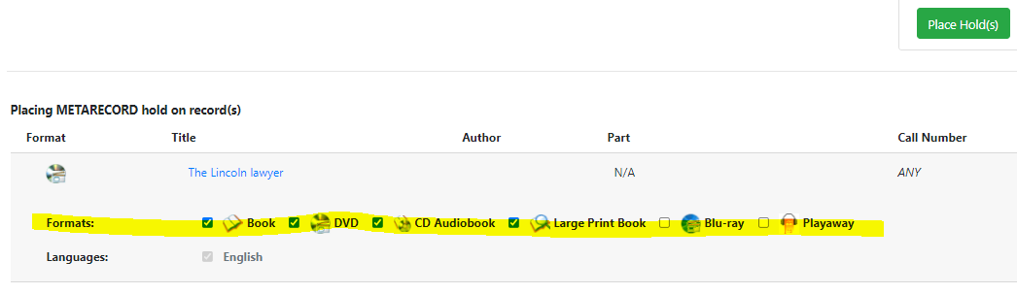

Placing Holds from a Catalog Search
Staff may place items on hold through the library’s catalog rather than through a patron account. To place a hold for a patron from the catalog, first perform a search for the desired item.

After clicking Place Hold, a confirmation screen will appear. On this screen, you will need to enter the patron’s barcode. If you don’t have access to the patron’s number, you may perform a Patron Search from the button next to the Barcode field.

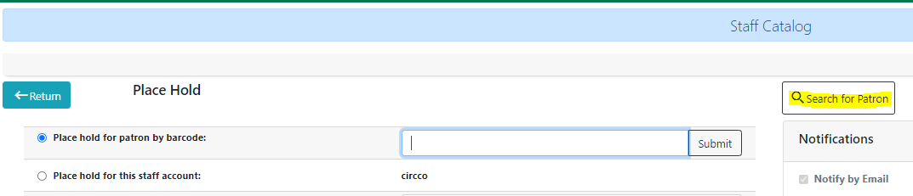

Click Search for Patron and Select the correct patron from the search results.

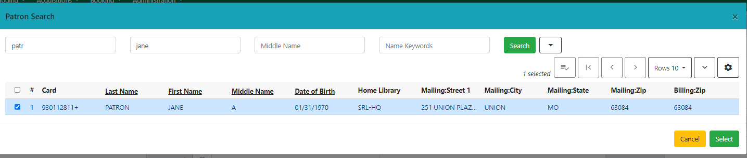
The patron’s name, barcode number, and notification preferences will automatically populate the Place Hold screen. Verify the information with the patron and click Place Hold to complete the process.

Baskets
When placing holds on multiple items for a single patron, a Basket may be used to save time. As items the patron wants are found in the catalog, they may be added to a basket and holds placed on all items in the Basket at one time. Items with parts (series DVDs) may not be added to a basket. These holds must be placed individually.

    - Perform a catalog search from the patron’s account.
    - From the search results, click the box next to the title to add the item to the Basket.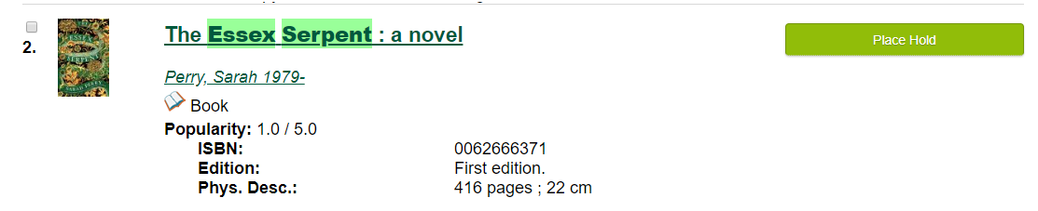
    - As each item is added to the basket, the number in the basket increases. You will find the basket icon at the top right of the page. 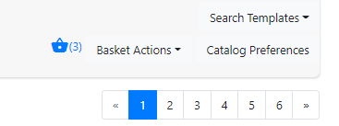
    - When all items that need holds placed are in the basket, select what you want to do with the basket from the Basket Actions dropdown menu.
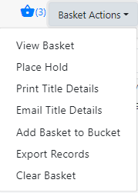
    - After you select Place Hold, you will see all of the titles that are being reserved and the patron’s contact information.
    - From this screen, you can perform all of the usual holds functions.
    - Items will remain in the basket until it is cleared or until the staff member logs out. After placing the holds from the basket, access Basket Actions again and select Clear Basket. (The basket is not specific to the original patron. It will carry over to every patron for whom you place a hold unless you clear the basket.)

Editing Holds
Changes may be made to existing holds by selecting the item that needs to be changed and clicking on the Actions dropdown.

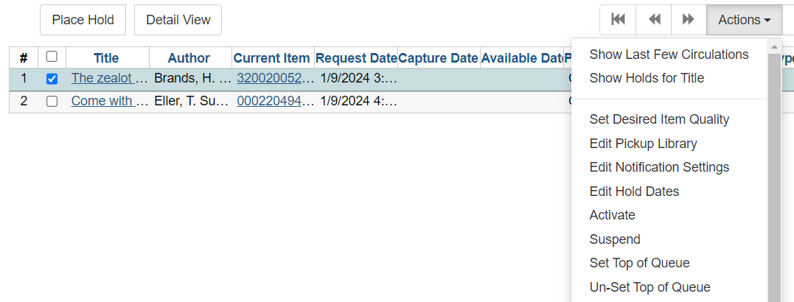

Canceling Holds
Holds can be canceled through the patron record. Display a patron’s holds by clicking the Holds action button.
- Select the hold the patron wishes to cancel.
- Select Cancel Hold from the Actions menu. This option appears at the bottom of the list.
- When the pop-up window appears, choose a Cancel Reason from the dropdown menu. Add a note explaining why the hold was canceled. For example, if a patron changes their mind about wanting something that was requested, add this information in the note window. Be sure to add your initials in the text box. This note can be accessed later if a question arises about why a hold was canceled.
- Click Cancel Hold and the hold will disappear from the list on the patron’s record.
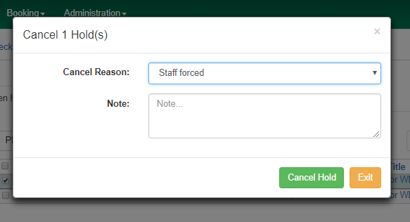
At any time, staff may view cancelled holds by clicking the Recently Canceled Holds button on the Holds screen. This is helpful when a patron wants to again request an item whose hold expired or was cancelled. If a hold needs to be restored, it can be un-canceled. To un-cancel a hold, follow the instructions below:
            - Click Recently Canceled Holds.
            - Highlight the hold you wish to un-cancel.
            - Select Uncancel Hold from the Actions menu.
            - The item will reappear in the active holds list with the original request date.
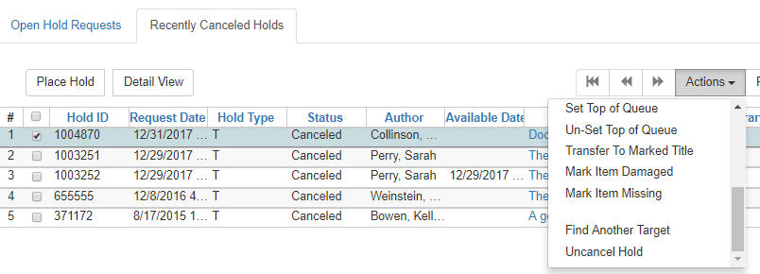

The note written by staff when canceling a hold can be viewed through the Recently Canceled Holds screen. To view the cancel cause and notes, follow the instructions below:
    - Click Recently Canceled Holds.
    - From the Column Picker, make sure that Cancel Cause and Cancelation Note are checked.
    - Cancel Cause shows the Cancel Reason that was selected when the hold was canceled.
    - Cancel Note shows the message written by staff to explain the cancelation.

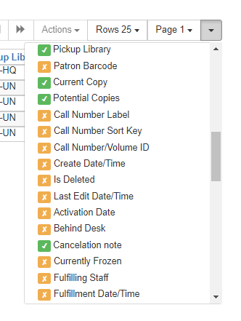
To save columns on this page, select Save Columns from the Column Picker.

Suspending and Activating Holds
If a patron does not want a hold to be filled immediately, staff may suspend the hold. Suspending a hold prevents the hold from being filled until a specific date or indefinitely. This can be done when placing the original hold or at a later time from the patron’s record. See Placing Holds from the Patron Record

Suspending Holds Indefinitely
      - From the Holds screen of the patron’s record, select the hold that the patron wishes to suspend.
      - Select Suspend Hold from the Actions menu.
      - A pop-up window will appear verifying that you would like to suspend the hold. Click Yes.
      - The status of the selected hold will change to Suspended on the patron’s record.

Suspending Holds Until a Specific Date
      - From the Holds screen of the patron’s record, select the hold that the patron wishes to suspend.
      - Select Edit Hold Dates from the Actions menu.
      - A pop-up window will appear. Check the Holds Activation Date box. Select the date that you would like to activate the hold. This will be the date that the item will show up on pull lists again.
      - Click Submit.

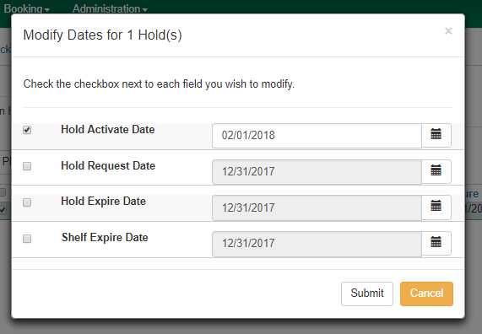
The process to activate a suspended hold is very similar. When the patron asks you to activate a hold, follow the instructions below.
    - From the Holds screen of the patron’s record, select the suspended hold that you wish to activate.
    - Select Activate from the Actions menu.
    - A pop-up window will appear verifying that you would like to activate the hold. Click OK/Continue.
    - The status of the selected hold will change to Waiting for Copy on the patron’s record.
    - Holds can be suspended at the same time as they are placed. Look for this feature when you know the patron does not want to receive the item immediately. The date entered will be the date that the item will show up on pull lists again.

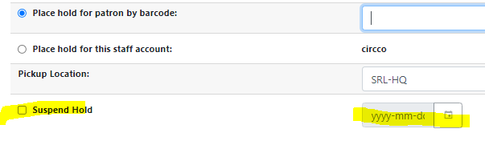

Pulling Holds
Requested items appear on the circulating library’s Pull List for Hold Requests report. This report can be accessed in Evergreen, by selecting Pull List for Hold Requests in the Circulation dropdown menu.

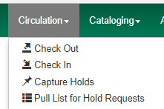

The resulting list shows items to pull from your shelves to fill holds for patrons of both your library and other Missouri Evergreen libraries.
The default setting is to show 25 rows. There is the option of viewing up to 100 rows in the dropdown menu.
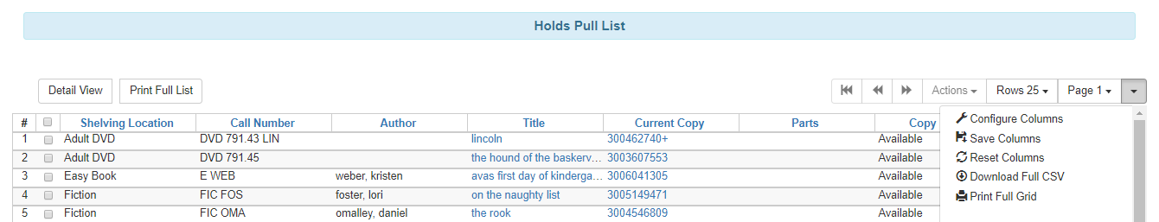

The list will need to be printed so that staff can pull items from the shelves to fill holds. To print the list, open the Column Picker and select Print Full Grid. Items on request should be pulled at least once a day. Columns can be configured with your library’s preferences. Columns must be saved to be view the next time you print.

Capturing Holds
After printing this list, holds will need to be retrieved from the shelves and captured in Evergreen. To capture a hold, follow the instructions below:

    - Open the Check In screen.
    - Check in the pulled items.
    - If the item has a hold at your branch, follow your procedure for attaching Hold Shelf Slips.
    - If the item is filling a hold at another branch or library, put the transit slip in the middle of the item with the library code visible above the pages and stage the item according to your library’s procedure. Audio visual materials should have the transit slip placed between the clear plastic cover and the paper liner.

Once an item is added to the holds shelf, the patron needs to be notified based on your library’s procedures. For patrons who choose to be notified by email or text message, the notification is automatically sent.

Retargeting Holds
Holds not captured within 24 hours of being placed will automatically retarget a different item if there is another available item on the same record. When an item remains on the pull list for more than 24 hours, your copy is the only one showing as Available in the catalog. Change your copy’s status to Missing if you can’t find it.
After changing the item’s status, search the catalog for a copy of the item on a different record. Place a hold for the patron on the new record. If no other copy is available, the hold will appear in the home library’s Hopeless Holds report.

Clearing the Hold Shelf
When items have been on the holds shelf for the period of time set by the library, they are considered expired. These items will need to be removed from the hold shelf and routed as directed by Evergreen.
To find shelf expired holds, select Holds Shelf from the Circulation menu on the Home screen. This will bring up the list of all holds currently on your hold shelf.
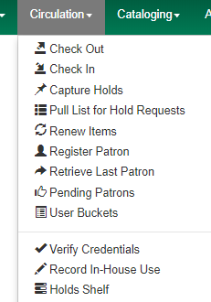

To view expired holds, check Show Clearable Holds.

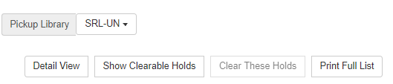
Use the column picker to select columns so that you are able to easily find the items that need to be removed from the hold shelf.
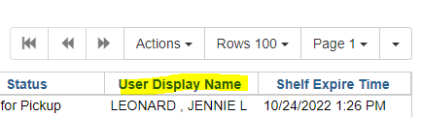
Print the list and retrieve the expired holds from the holds shelf. If all items on the list are found, select all the items and click the Clear These Holds button. Expired holds may also be canceled individually by highlighting the hold(s) and choosing Cancel Hold from the Actions menu. All canceled holds must now be Checked In to trigger the next hold, a transit slip, or reshelving.

Home Library item not found on Hold Shelf
If an item on the list that belongs to your library is not found, call the patron to see if he picked it up and didn’t check it out. If the patron doesn’t have the item, cancel the hold and mark the item Missing. You may need to place the hold for the patron again if he still needs it.

MEC item not found on Hold Shelf
If an item on the list that belongs to a different library isn’t found, call the patron to see if he picked it up and didn’t check it out. If the patron doesn’t have the item, contact the owning library to see if they have it. If they don’t, cancel the hold and ask the owning library to mark it Missing. You may need to place the hold for the patron again if he still needs the item.
If the status of an item on the Holds Shelf is Wrong Shelf, the patron has chosen a different pickup location. Check In the item to trigger a transit slip to the new pickup location.
If the status of an item on the Hold Shelf is Canceled, the patron canceled the hold himself. Remove the item from the Hold Shelf and check it in to find out how it should be routed next.

Hold Groups
By joining Hold Groups, patrons will have holds automatically placed on new books by popular authors. Patrons are able to remove themselves from a Group but cannot add themselves to a Group. Staff perform that function.

- Perform a patron search. (Do not scan a library card into Checkout. The magic won’t work by entering data into Checkout.)
- Select the target patron from the results.
- Click the Add to Bucket button.
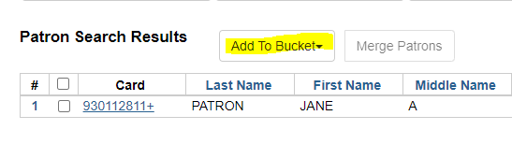
- Select the author whose Hold Group the patron wants to be added to.
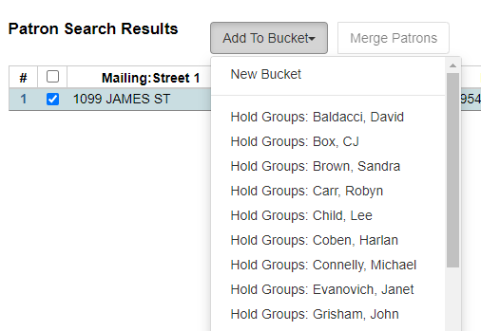
- A confirmation will appear at the bottom right of the screen. 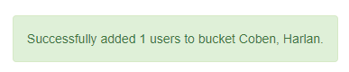
- In the patron account, you can check Other > Hold Groups to verify the patron is in the group or to remove the patron from the Hold Group. 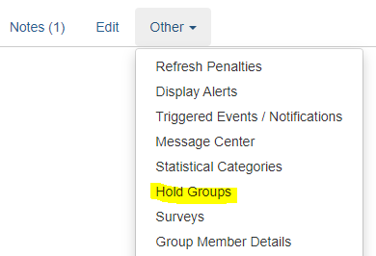

Bills
Libraries charge patrons for a variety of reasons including lost items, damaged items, replacement cards, and out-of-district fees. Bills for lost and damaged items are called circulation bills. They are automatically generated by Evergreen. All other bills are called grocery bills. They are manually entered by staff.

To access a patron’s bills, go to the patron record and click on the Bills action button.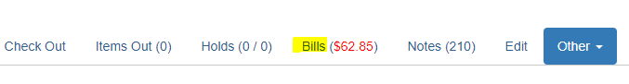
Clicking on Bills takes you to the patron screen showing individual bills and where payment can be entered.
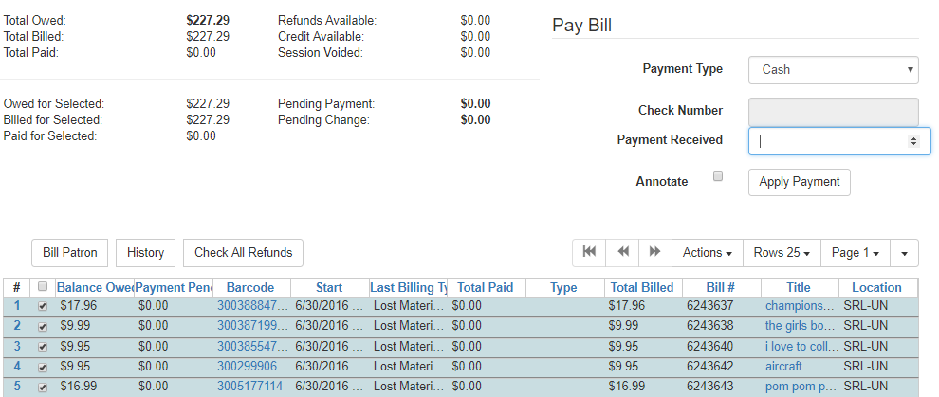

Paying Bills
Payments are kept at the library where they are made. Checks should be made out to the library where the bill is being paid. If the patron is paying for an item not belonging to the home library, it is the responsibility of the owning library to send an invoice to the patron’s home library. To pay bills on a patron’s account:

    - Select the line for the bill that is being paid.
    - Choose the payment type from the Payment Type dropdown menu.
    - Enter the amount of the payment in the Payment Received box.
    - Make sure that the Annotate Payment checkbox is checked.
    - Click Apply Payment to record the payment to the patron’s account.
    - After applying the payment, a box will pop up asking for an annotation. Staff enter their initials in this box. Other important information may also be entered in this field. The workstation library and date will automatically be added to the payment.
    - Click OK.
If the patron wants to pay for a specific item in the list of bills, make sure that the specific bill is the only one checked. Failure to check only one item in the list will cause the payment to be applied to the first item in the list, no matter what the amount of the bill is or what the amount of the payment is.

Voiding a Bill
Sometimes, staff may need to void a bill on a patron’s account. For example, the wrong patron was charged for damage to liner notes or a lost item is found on the shelf. In order to do so, bring up the patron’s account, and go to the Bills screen. Highlight the bill in the patron’s list of bills and select Full Details from the Actions menu:
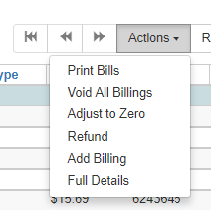
This will bring up the full details screen. On this screen, highlight the bill that needs to be voided, and click Void Billings in the Actions dropdown menu. No record of the bill will remain on the patron’s account.
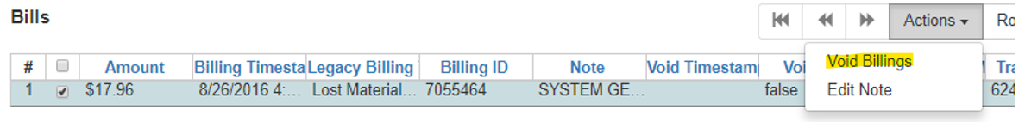

Forgiving a Bill
Voiding a bill leaves no record of the bill in the patron’s account. Sometimes, staff want to remove a bill while leaving a record of the transaction. Use the Forgive function for this purpose. Forgiven payments will appear in Bill > History the same way Cash or Check payments appear.

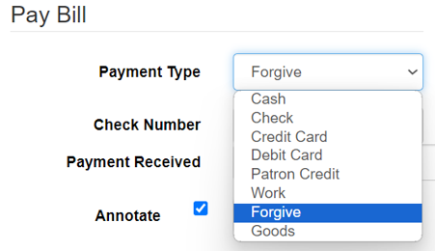
- Select Payment Type—Forgive
- Select the line item of the bill to be forgiven in the list of bills.
- Enter the amount to be forgiven in Payment Received.
- Make sure the Annotate box is checked.
- Click Apply Payment.
- Enter a full explanation of why the bill is being forgiven and your initials in the annotation box.
After a bill has been forgiven, a Note should be created in the patron’s account explaining the situation. The title of the note should be Forgiven. The text should include the item title, barcode, amount of bill being forgiven, and the reason the bill is being forgiven.

Keep in mind that forgiving a bill for an item that belongs to a different Missouri Evergreen library doesn’t prevent the owning library from sending an invoice to the borrowing library. That invoice must be paid even though the borrowing library isn’t receiving reimbursement from their patron.

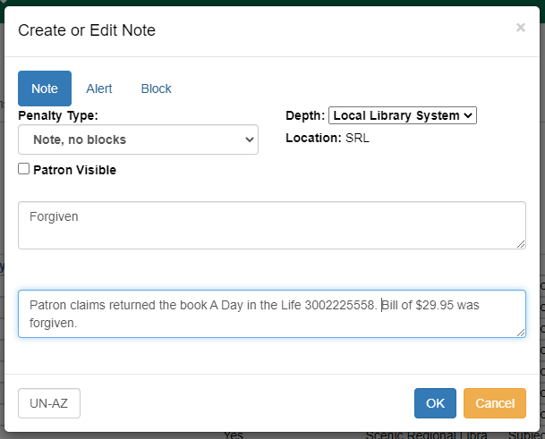

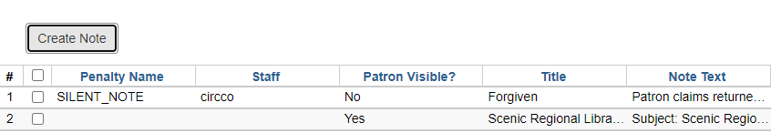

Grocery Bills
Grocery bills are bills that are not automatically generated by the ILS. These charges include replacement library cards, non-resident fees, partial damages, missing pieces, etc. Grocery bills must be manually billed and entered in a patron’s record. These are added from the Bills screen in the patron record.
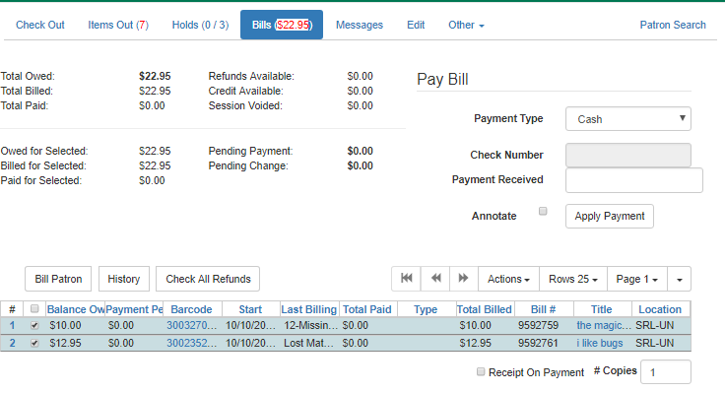
To add a grocery bill to a patron’s record, follow the instructions below:
- Click the Bill Patron button to create a grocery bill on the patron’s record.
- In the Create Bill screen, select the appropriate type from the Billing Type dropdown box.
- Enter the amount to bill the patron in the Amount box.
- Enter your initials, and the bill explanation if necessary, in the Note box.
- Click the Submit this Bill button to bill the patron.
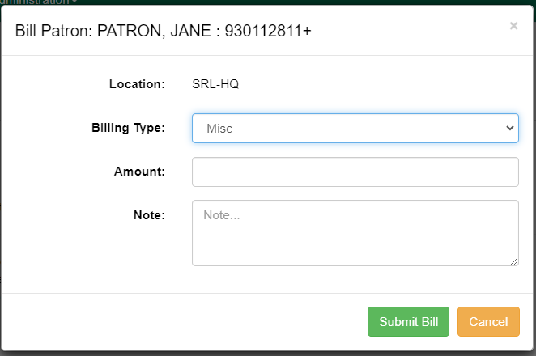

Lost Items
A circulation bill is created in the patron’s account when an item has been overdue by the limit set by the checkout library. The ILS pulls the price of the item from the item record to create the bill.

Patrons may also report to staff that an item has been lost. Staff will then change the status of the item from Checked Out to Lost in the patron’s account. The ILS will pull the price of the item from the item record to create a bill based on the owning library’s policies. Follow these steps if a patron reports loss:

- Highlight the lost item in the patron’s list of Items Out.
- From the Actions menu, select Mark Lost (By Patron).
- The item will move from Items Out to Other/Special Circulations.
- A bill for the lost item will be created.

If patrons want to know the amount they will have to pay if they lose an item, staff can find that information in Item Status > Detail View. Processing fees may be added to the price based on the owning library’s policies.

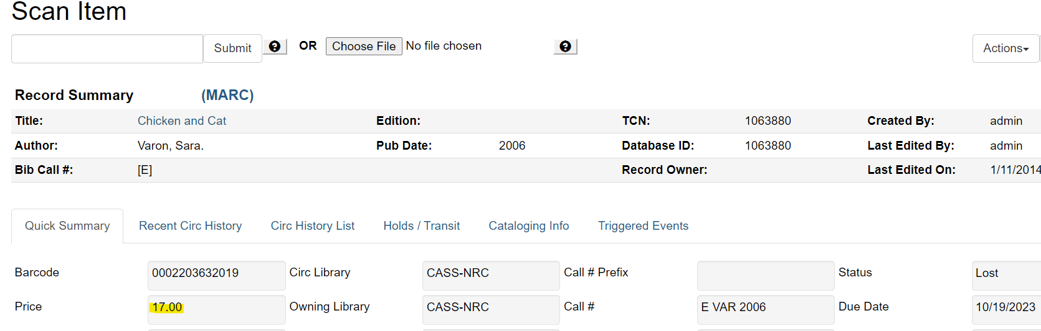

Checking Out When the Internet is Down

When Evergreen is not functioning or when internet service is interrupted there is an Offline Circulation Mode that can be used. See Appendix for Offline Circulation Using Evergreen.
However, libraries usually record transactions using other software such as Word, Notepad or Excel. Do not check in any items until Evergreen is restored.

Patrons must have their library card with them or the Missouri Evergreen mobile app on a mobile device so that their patron barcode can be scanned. To prevent checkout errors, numbers should not be handwritten or photocopied for later upload.
For simplicity, use one workstation to checkout materials. If that isn’t possible because of high demand, use two.

    - Open the document (Excel, Word or Notepad) your library uses to record offline checkouts at each workstation that will be used to check out.
    - Click File at the top left of the screen and select Save As.
    - Name the file, “Offline Checkout mm/dd/yyyy” and save to the desktop.
    - When checking out materials for a patron, scan the patron barcode. Do not enter manually.
    - Scan the item barcodes. Do not enter manually.
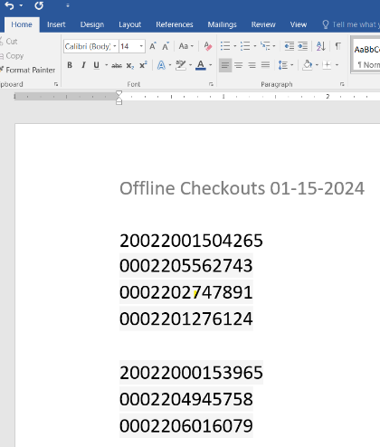

If using Word or Notepad scan the patron barcode, then scan the checkouts below.

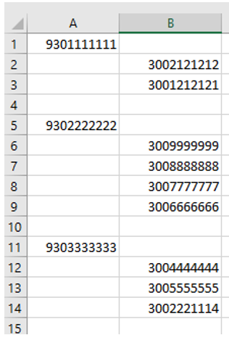

If using Excel, scan patron barcodes into
column A and item barcodes into column B.

    - Leave a blank line between patrons. (This process will reduce the chance of checking out the wrong materials to the wrong patron.)
    - SAVE after completing the checkout for each individual patron.
    - When access to Evergreen is restored, copy and paste patron and material barcodes into Evergreen Check Out. Do not manually enter the numbers. DO NOT Check In anything until all check out transactions have been entered.
    - If a patron account is expired and therefore blocked from checking out, edit the expiration date to the next business day so that check out is possible.
    - If the patron account is blocked, override the block so the materials can be checked out.
    - Delete any documents after all check outs are entered into Evergreen.

Appendix – Other Helpful Documents

Canceling Transits
http://moevergreenlibraries.org/wp-content/uploads/2020/11/Canceling-Transits.pdf

Checking the Transit List
http://moevergreenlibraries.org/wp-content/uploads/2020/12/Transit-List-December-2020.pdf

Damaged Items Best Practices
http://moevergreenlibraries.org/wp-content/uploads/2022/02/Missouri-Evergreen-Damaged-Items-Best-Practices-Guidelines.pdf

Deleting Expired Patron Accounts
http://moevergreenlibraries.org/wp-content/uploads/2024/02/Deleting-Expired-Patron-Accounts.pdf

Finding Shelf Expired Holds that are on Another Library’s Hold Shelf
http://moevergreenlibraries.org/wp-content/uploads/2024/02/Finding-Shelf-Expired-Holds-that-are-on-Another-Librarys-Hold-Shelf.pdf

Hopeless Holds
http://moevergreenlibraries.org/wp-content/uploads/2022/10/Hopeless-Holds.pdf

How to Spot a Fake/Bootleg DVD
https://www.wikihow.com/Spot-Fake-DVDs

Materials Handling Best Practices
http://moevergreenlibraries.org/wp-content/uploads/2024/04/Materials-Handling-Best-Practices.pdf

Missouri Evergreen Circulation Policy
http://moevergreenlibraries.org/wp-content/uploads/2022/12/Circulation-Policy-revised-12_01_22.pdf

Offline Circulation Using Evergreen
TO AVOID CIRCULATION ISSUES, ONLY USE THE CHECKOUT FEATURE. UPLOAD AND PROCESS ALL TRANSACTIONS BEFORE CHECKING IN ANY ITEMS.
https://docs.evergreen-ils.org/docs/latest/circulation/offline_circ_webclient.html - _using_offline_circulation

