Missouri Evergreen Circulation Committee Minutes
Tuesday, May 26 at 11am

- New Business
  - Multiple libraries have indicated there has been an uptick in the number of items sent in transit with missing pieces, significant damage or foreign objects inside pages. Libraries were encouraged to check that items are complete and in reasonable condition before sending them to another library.
  - The MEC Consortium Cataloger shared information about the plan to enable the setting requiring monograph parts for all items when any item on the record contains a monograph part. This change will take place June 1st and would not be retroactive so there will be no need to re-catalog items already separated into parts. The committee also discussed the possibility of requiring “Complete Sets” instead of breaking sets into individual parts.
  - Darcy Humphrey asked the Consortium Cataloger about a situation in which the system was selecting which magazine issue a patron would receive. The hold screen did not appear to provide a place to select a specific issue. Liz had not previously encountered that behavior. Hopefully, it was an anomaly and the new monograph part changes will prevent the problem in the future.
  - Currently, Evergreen’s default setting changes an item’s status to Damaged when it is Marked Missing Pieces. The committee requested that all libraries check their Library Settings for Missing Pieces and change their setting to Missing Pieces if necessary. Instructions can be found at the end of the minutes.
  - Regional Circulation Training is coming this fall. The committee will send an official Save the Date reminder and a survey to inquire about topics libraries would like included in the training. Additional information will made available after we review the survey responses. Dates and locations for the upcoming training days are:
- September 11th at Camden County
- September 18th at Jefferson County
- September 25th at Poplar Bluff
- October 9th at Livingston County
- October 22nd at Carthage
  - The committee presented a new, larger version of the MEC Item Condition Report. The hope is that it will be harder for patrons and staff to misplace or overlook. A few tweaks were suggested, and Darcy Humphrey agreed to make those changes before the report is posted.
  - Kessie Osborne, from Ozark Regional, asked whether there was a way to add notes to holds as they are being placed instead of having to wait until the hold is created. The suggestion was made that she should submit a “wish list” suggestion to Equinox in hopes that a developer could add a note field to the hold placement screen.
  - Kessie also sought feedback on situations where a patron places a hold on an On Order record, but when the item arrives, it immediately goes into Age Protection instead of going to the patron. At this time, about 20% of the consortium still uses 6-month age protection, although many libraries have moved to shorter age protection periods. Patron education is necessary so patrons understand the potential delays that might be involved when placing holds on newly ordered items, especially popular titles.

- Old Business
  - Courier Label updates: Please make sure your library is using Get Connected
MALA Courier LABELS version 57— 4/15/2026
- Periodically check that all “old” labels have been destroyed so that items do not accidently receive an “old label.
- Other
  - Centralia Public Library’s go live date is May 28th, resource sharing is scheduled to begin 2 weeks later.
  - Our next meeting will be June 23, 2026

Committee Members:
Heather Arnold harnold@mlc-stl.org
Belinda Birrer assistantdirector@poplarbluff.org
Rhonda Busse busser@casscolibrary.org
Janice Butcher jbutcher@dspl.missouri.org
Christal Haueter chaueter@lebanon-laclede.lib.mo.us
Darcy Humphrey dhumphrey@carthagelibrary.net
Jennifer Mathes jmathes@jeffcolib.org
Madison Morris mmorris@wgpl.org
Terri Moser terri@neosho.lib.mo.us
Lee Ann Santee leeann@blrlibrary.org

Instructions for Setting Missing Pieces Status

By default, marking an item as Missing Pieces checks it back out to the last patron and changes the status of the item to Damaged. That status is confusing since the item isn't Damaged. We now have the option to change the item status to Missing Pieces. To change your library's setting from Damaged to Missing Pieces, follow these steps:

- Open Administration > Local Administration > Library Settings Editor.

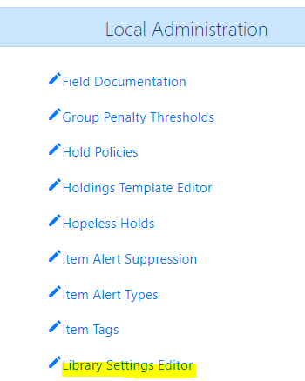
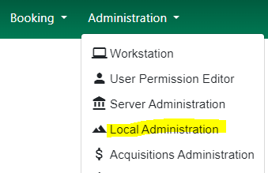

- Enter your library in Context Location and type missing pieces in the empty field. Then click Edit on the Item Status for Missing Pieces line.

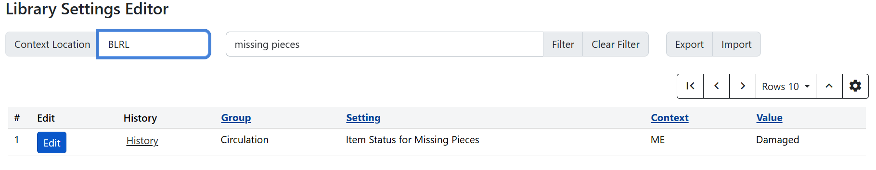

- From the Edit Setting popup verify your library is in the Context field and choose Missing Pieces for the Value field. Then click Update Setting.

